CAS PY 106

Lecture Note 25

1. Maxwell’s equations
2. Equation 1: Electric fields point straight out of charges (or into)
3. 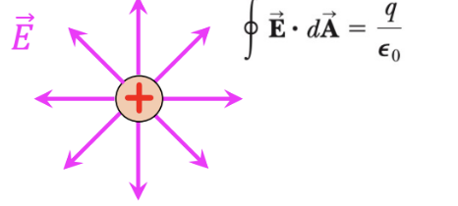
4. Equation 2: Magnetic field lines form continuous loops (magnets are dipoles)
5. 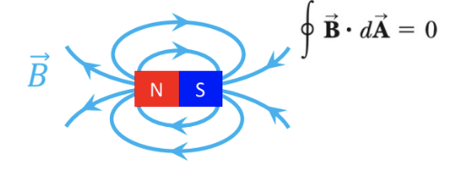
6. Equation 3: Changing magnetic flux produces an electric field
7. 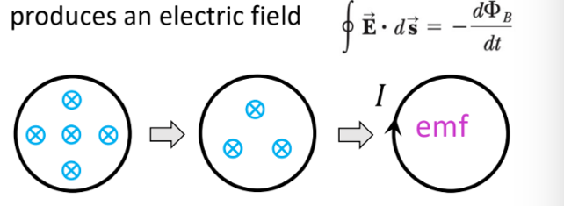
8. Equation 4: Magnetic fields come from currents, or from changing electric flux
9. 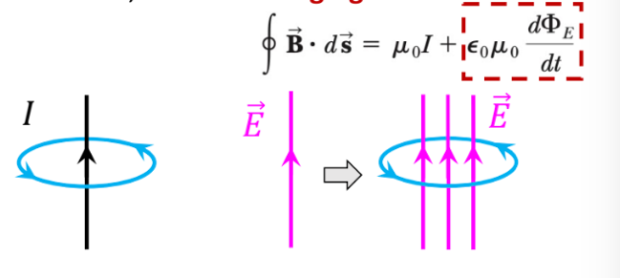
10. Electromagnetic Waves
11. Maxwell derived a solution for these equations

* E(x,t) = Emaxcos(kx-wt)
* B(x,t) = Bmaxcos(kx-wt)

1. 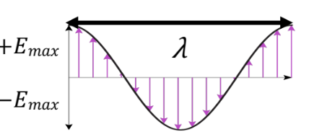
2. Oscillating electric and magnetic fields travel as waves, predicted to have a speed:

v = frequency \* wavelength =(w/2pi)\* (2pi/k) = w/k = 1/sqrt(e\*u) = 2.998\*10^8m/s

where e = permittivity of free space constant = 8.85 \* 10^-12

and u = permeability constant = 4pi\*10^-7

1. Maxwell realized that this was close to measured values for the speed of light, and that traveling waves of electric and magnetic fields must be the origin of light
2. This unifies electricity, magnetism, and optics!
3. Electromagnetic (EM) waves
4. 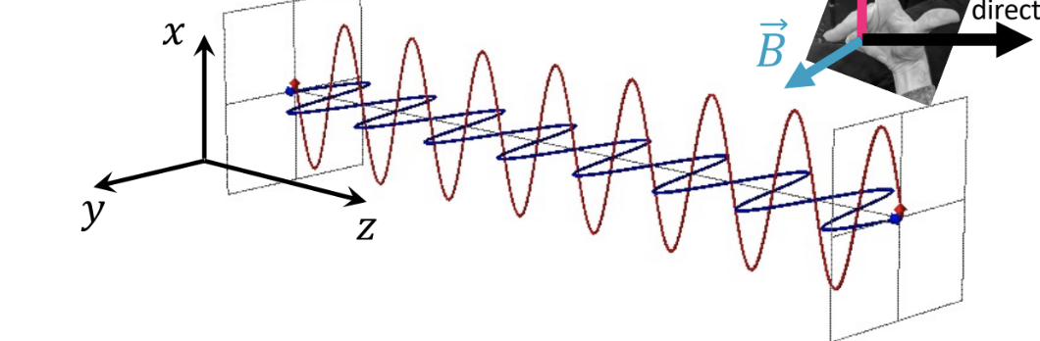
5. 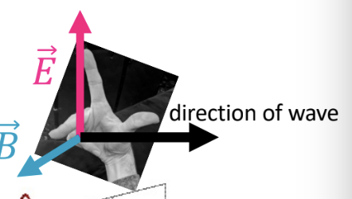
6. Notice how the E-field vector is oscillating up and down on the x-axis and the B-field vector is oscillating left to right on the y-axis (in phase with the E-field)
7. Wave travels in z-direction
8. Direction: E x B (right-hand rule)
9. EM waves do not need a medium, unlike sounds (medium is air, water, etc.) or waves on a string (medium is the string)
10. The electric and magnetic fields are also related to speed of light: v = c = E/B
11. The Electromagnetic Spectrum
12. V = c = frequency \* wavelength = 3 \* 10^8
13. 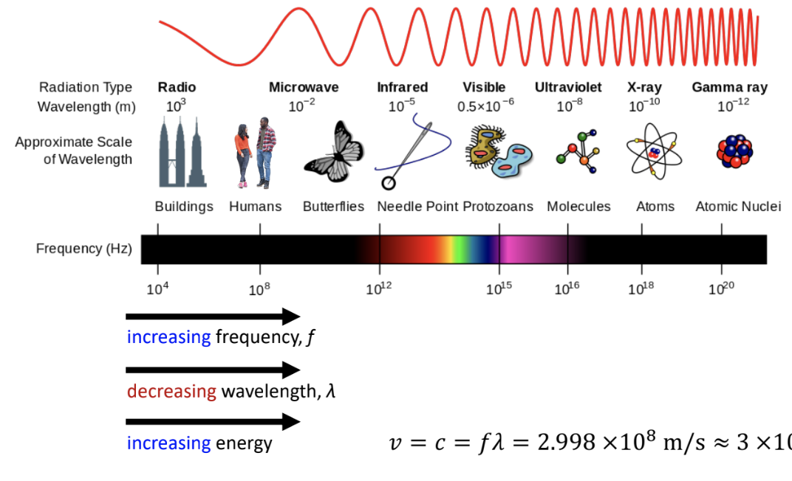
14. How do you make an EM wave?
15. One method requires moving electrons back and forth along a conducting rod (antenna)
16. 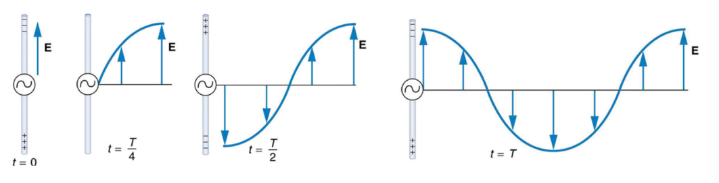
17. When the electrons are on one end of the antenna at time t, the E-field in that direction
18. As electrons are shifted to the other end of the antenna, the E-field turns around and points in the other direction.
19. The E-field amplitude continues to oscillate while propagating outward
20. While the E-field is oscillating and propagating outward, there’s also a B-field oscillating back and forth around the antenna, because the moving electrons form an electric current
21. The B-field also propagates outward with the E-field
22. Energy and Intensity
23. Energy in a magnetic field
24. U/vol = ½ \* e \* E^2 + 1/(2\*u) \* B^2
25. Intensity = power/area = energy/time \* 1/area
26. 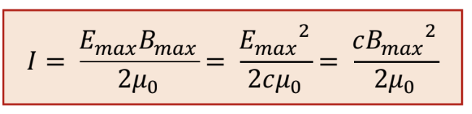
27. 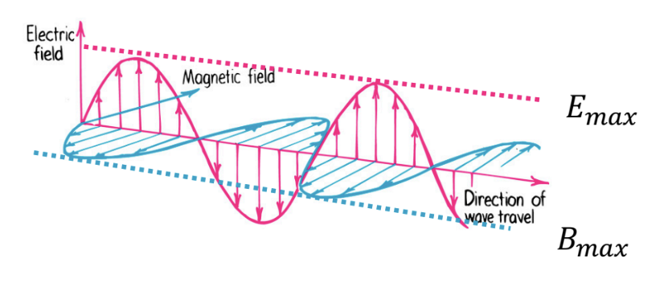
28. EM waves carry energy and momentum
29. Light has no mass, but it carries momentum
30. Light carries momentum in the form of energy related by E = pc
31. Momentum conservation always holds, so light reflecting from a surface transfers twice as much momentum as light absorbed
32. We often look at this as radiation pressure – light incident on a material is associated with a force over the area of the beam – a pressure
33. Radiation pressure
34. Radiation pressure when all energy is absorbed:

* Absorbed: P = I/c
* Momentum before is +p, and after is 0, so +p is transferred to the surface

1. Radiation pressure when all energy is reflected straight back:

* Reflected: P = 2I/c
* Momentum before is +p, after is –p, so +2p is transferred to the surface